**Introduction to Circuits**

In this tutorial you will learn basic soldering and circuit design.

***Part I: Soldering leads on a battery***

WARNING: Soldering irons are very hot and will burn you or the table. Do not leave plugged in if unattended.

Solder solid core wire leads onto a battery connector so it can fit in a breadboard.

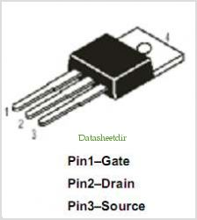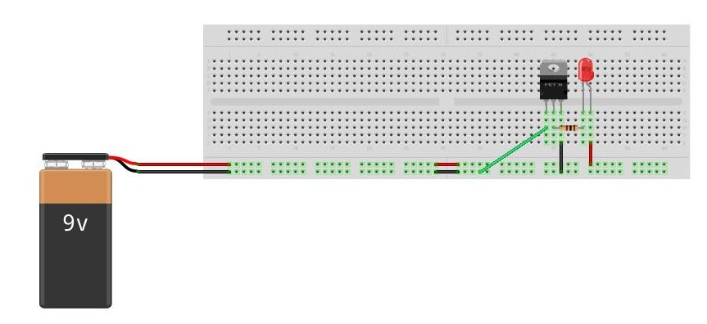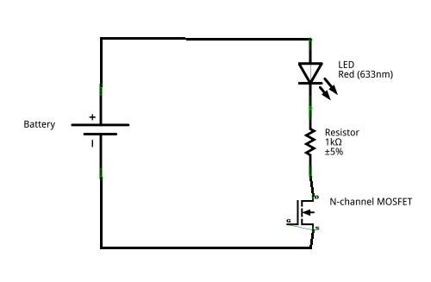***Part II: Using a MOSFET***

1. Construct the above circuit on a bread board

Gate

1. Connect the Gate pin of the MOSFET to either 5V or GND alternatively (NOT BOTH AT THE SAME TIME)
2. Observe the LED.

***Part III: Making an adjustable voltage divider***

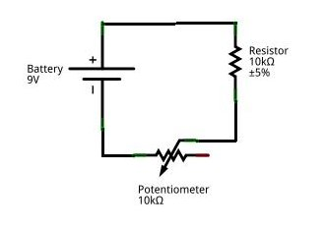

NodeA

1. On a different part of the breadboard, construct the above circuit
2. Predict the value of the potentiometer needed to get 4V in the middle of the voltage divider.
3. Obtain a Digital Multimeter(DMM)
4. Use the DMM to monitor Node A
5. Adjust potentiometer until Node A is at 4V
6. Use the multimeter to measure the value of the potentiometer
7. Is this the expected resistance? If not, why?

***Part IV: Turning on an LED***

1. Without changing the potentiometer, connect Node A to the Gate of the MOSFET
   1. Is the LED on or off?
2. Adjust the potentiometer until the LED turns off
   1. What is the voltage at which the MOSFET switches from on to off?